**Project Report**

**1.INTRODUCTION**

In daily life, the Internet of Things (IoT) is extremely important. A central role for the Internet of Things is being found in many company automation plans. Businesses are utilising sensors in the logistics chain to track deliveries with incredibly accurate location data. The necessity for kid safety is growing in today's world as there is a possibility that a young child could go lost in a crowded area, which is the inspiration for this wearable.

This essay focuses on the crucial idea that, until they are reunited with their parents, those closest to a missing kid can help ensure their safety. An SMS and phone calls are sent to the parent's mobile phone if the sensor reports any abnormal values. Additionally, it updates the parental app via the cloud. The method includes GSM and GPS modules for SMS communication between the parental phones and the safety device as well as for making and receiving calls.

In order to integrate IoT, the system also includes a Wi-Fi/cellular data module that transmits all of the observed parameters to the cloud for parental phones to monitor. When a panic attack occurs, the panic alert system is utilised to send notifications to the parents' phones, which include pleas for assistance and updates to the alert's parameters. The majority of wearable devices currently on the market are designed to inform parents of the child's whereabouts and activity

1.1 Project Overview

This device allows for the tracing of the child's geolocation and the remote collection of data such as the child's location, a distance, etc. to display actual data from the child together with reference values. enables notice transmission in cases where the youngster is missing or when the gadget detects unusual circumstances. Create a working model of an Internet of Things (IoT) wearable smart band that can be connected to parental mobile apps to enable real-time monitoring of children's conditions wherever they are.

1.2 Purpose

These days, kids lack a sense of security and face numerous security-related problems. Many family members now spend more time working and fulfilling their societal obligations, which includes caring for their children. The situation in our nation right now is unsuitable for keeping an eye on kids. It is challenging to keep an eye on the kids constantly in the absence of a child surveillance system. Where Young children may act impulsively and choose impulsive locations. The majority of human behaviour is formed in the formative years, hence kid monitoring systems are essential to understanding this behaviour. Accidents and events frequently involve children. Due to their inability to defend themselves, children's safety is absolutely essential. The major goal of this project is to develop a smart wearable gadget for kids that makes use of cutting-edge technology to ensure their safety, The article offers a clever Internet of Things-based method for preventing kids from becoming lost when out with their parents or by themselves (IOT). Our suggested approach will ensure the highest level of security and provide live tracking for children. It suggests a concept for kid safety using cellphones that allows parents to follow their children's locations and instantly receive their precise coordinates. The security situation of the youngsters is assessed everywhere by monitoring the activities

**2.LITERATURE SURVEY**

2.1 Existing problem

The voice recognition module we utilise in the current system records and stores the child's alert instructions for later usage. If the same child issues the same command, it will check to see if an alert command has already been recorded and adjust the emergency level accordingly. To call or send alarm messages to people you can trust, the GSM has a SIM capability. GPS is utilised to track the current location as necessary. The server will help alert the registered guardians by looking up the right device ID in the database, finding the necessary contacts using that device ID, and using those contacts.

2.2 References

[1] Authors: Lai Yi Heng,Intan Farahana ,Binti Kamsin. Published in:2019 Title:IOT-BasedChild Security Monitoring System

[2] Authors: K. N. H. Srinivas, T. D. S. Sarveswara Rao, E. KusumaKumari.Title:Smart IoT Device for Child Safety and Tracking. Published in: 2019IEEE. <https://ijsrcseit.com/paper/CSEIT206288.pdf>

[3] Authors: AnandJatti, MadhviKannan, Alisha R M, Vijiyalakshmi P, ShresthaSinha.Published in 2016.Title: Design And Development of an IOT Based Wearable device for the safety and security of women and girl children

[4] Authors: Sarifsh Putri Raflesia, Firdaus, Dinda Lestarini . Published in 2018.Title: An Integrated Child Safety Usinf Geo- fencing Information on Mobile Devices

[5] Authors: Mrs.Chitra P,Aarthi S,Anitha K,Angammal R,Abinaiya D . Published in 2022.Title: Monitoring and Prevention Of Child Abuse Using IOT

[6] Authors: Dipali Badgujar,Neha Sawant,Dynaneshwar Kundande . Published in 2019.Title: Smart and Secure IOT based Child Monitoring System

2.3 Problem Statement Definition

An app that tracks and keeps track of a child's whereabouts is called a child tracking system. Every parent is aware of how challenging it is to constantly watch over and locate their children. It would be great if a device was available that could track a child's whereabouts constantly and notify them via text message. Making an IoT-based safety device that can send an SMS to the child's parents or caretakers to let them know something is wrong will alleviate their anxieties. The database stores the information that the device is tracking. A notification will be issued if the child leaves the geofence thanks to the design of the gadget.

**3.IDEATION & PROPOSED SOLUTION**

3.1 Empathy Map Canvas

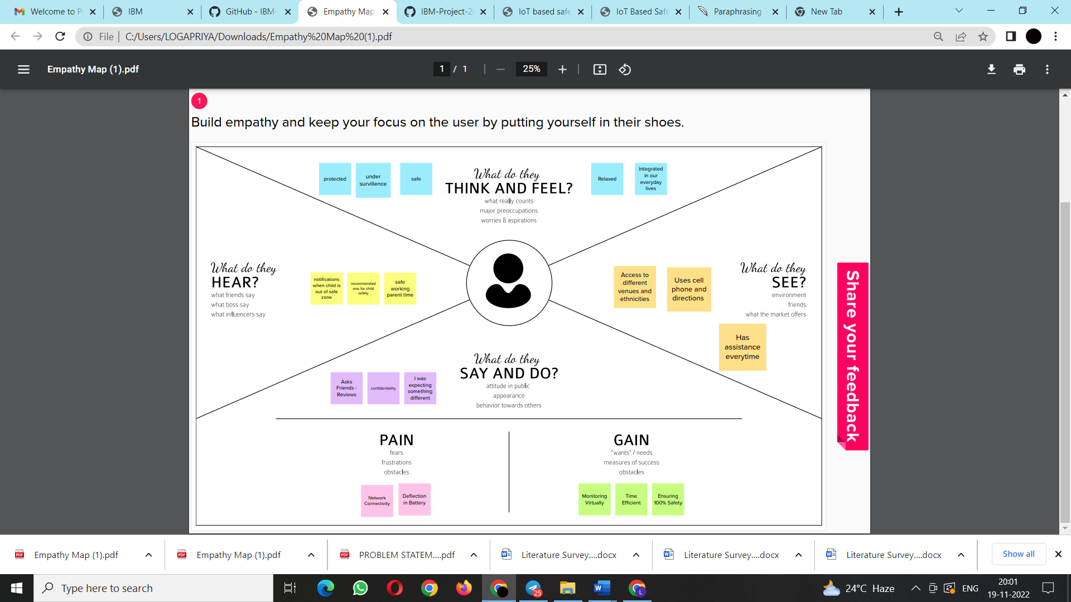

3.2 Ideation & Brainstorming

Step-1: Team Gathering, Collaboration and Select the Problem Statement

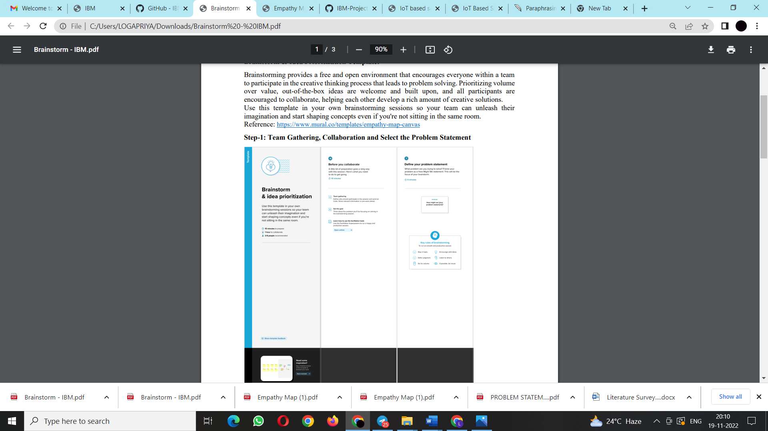

Step 2: Brainstorm, Idea Listing and Grouping

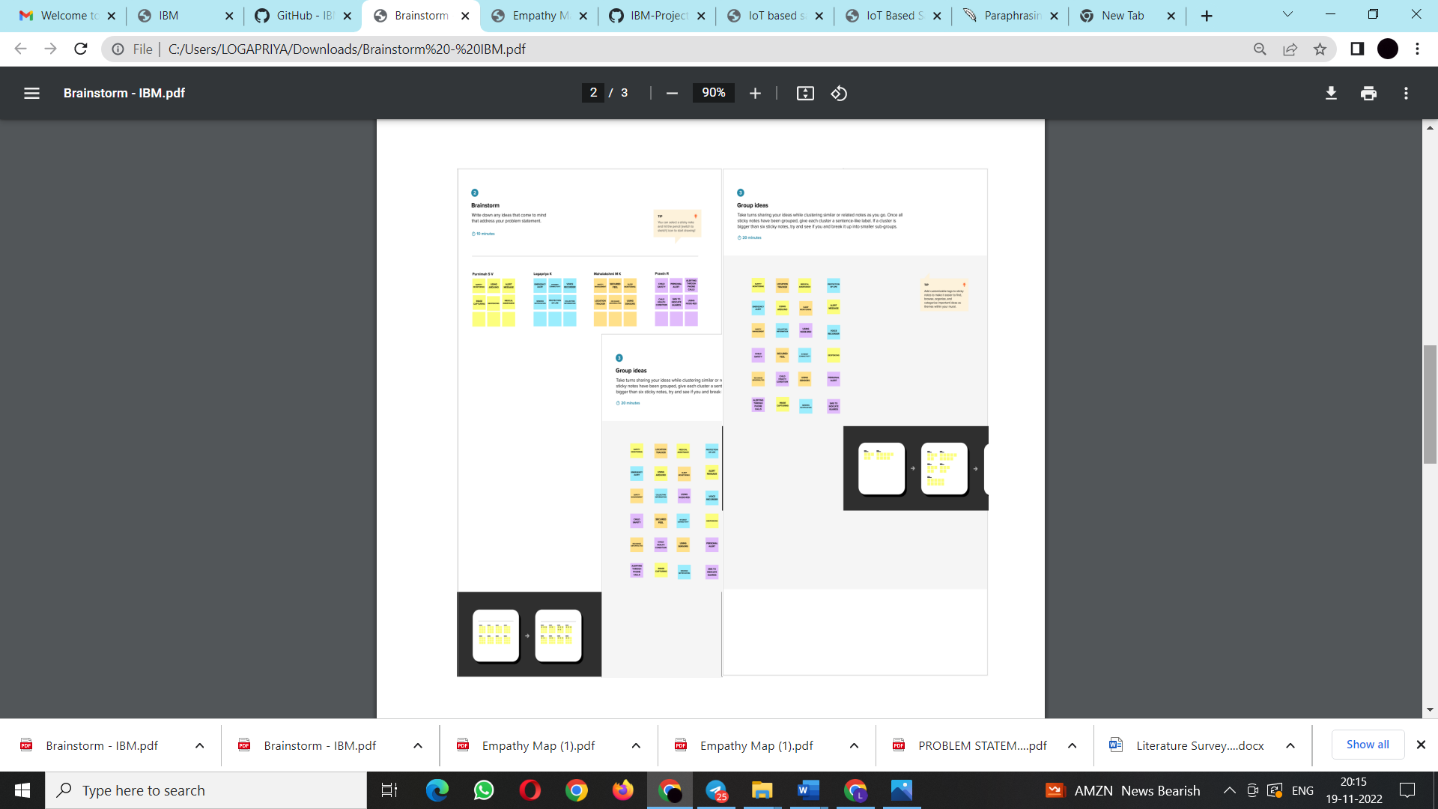

Step 3 : Idea Prioritization

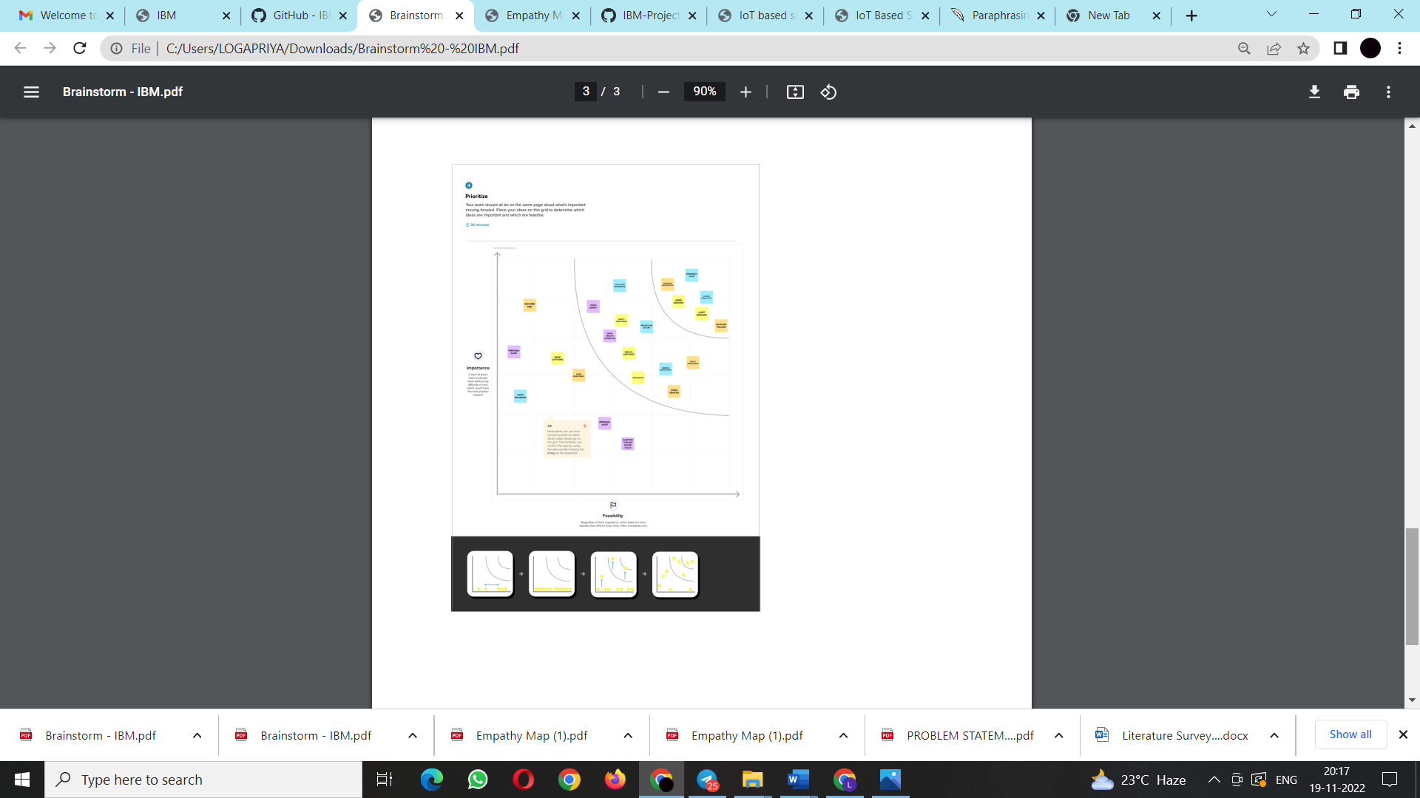

* 1. Proposed Solution

Project team shall fill the following information in the proposed solution template.

|  |  |  |
| --- | --- | --- |
| **S.No.** | **Parameter** | **Description** |
|  | Problem Statement (Problem to be solved) | An app that tracks and keeps track of a child's whereabouts is called a child tracking system. Every parent is aware of how challenging it is to constantly watch over and locate their children. It would be great if a device was available that could track a child's whereabouts constantly and notify them via text message. Making an IoT-based safety device that can send an SMS to the child's parents or caretakers to let them know something is wrong will alleviate their anxieties. The database stores the information that the device is tracking. A notification will be issued if the child leaves the geofence thanks to the design of the gadget. |
|  | Idea / Solution description | To create a device that tracks the child's position continuously. By continuously tracking the child's whereabouts, alerts will be sent out if they venture outside the geofence. This device notifies the child's guardians or parents of their whereabouts. |
|  | Novelty / Uniqueness | The notice is sent by the device so that the youngster passes the specific geofence. A database contains the tracked data. They can set up a geofence and keep an eye on their youngsters wherever they are going. |
|  | Social Impact / Customer Satisfaction | The device so made is simply accessible by creating the necessary geofence and delivering notifications right away as the youngster leaves the designated region. |
|  | Business Model (Revenue Model) | The device can be created to be small, wearable like a wristwatch, and cost-effective in order to be purchased by everyone and provide benefits. As a result, the sales and revenue will increase. |
|  | Scalability of the Solution | Their knowledge of automation will increase as a result of the IoT-based solution, and the expandability it offers will revolutionise more scalable monitoring systems. |

3.3 Problem Solution fit

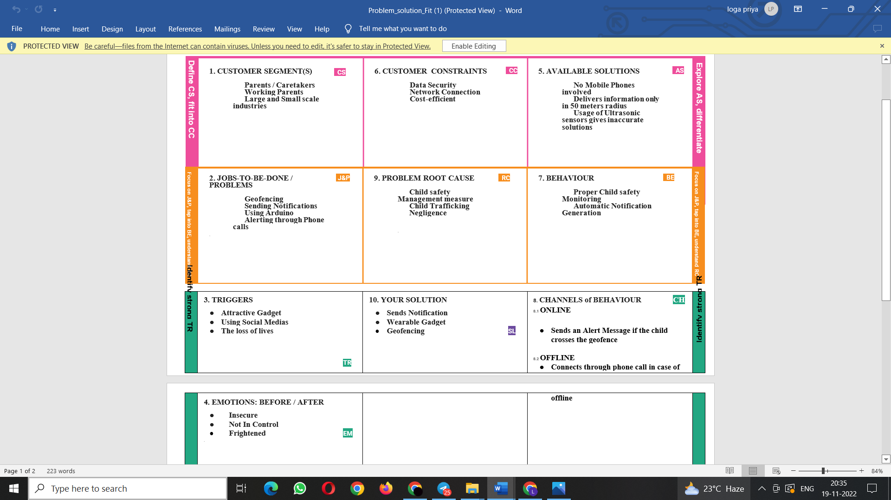

**4.REQUIREMENT ANALYSIS**

4.1 Functional requirement

Following are the functional requirements of the proposed solution.

|  |  |  |
| --- | --- | --- |
| **FR No.** | **Functional Requirement (Epic)** | **Sub Requirement (Story / Sub-Task)** |
| FR-1 | User Registration | Registration through Gmail |
| FR-2 | User Confirmation | Confirmation via Email |
| FR-3 | User Authentication | User Verification through valid user Id and password |
| FR-4 | User Access | Real Time monitoring of child’s location through web portal for authorized users, |
| FR-5 | User Alert | User receives alert notifiation of child and will be able to track the location |
| FR-6 | Review and feedback | Receive feedback from user |

* 1. Non-Functional requirements

Following are the non-functional requirements of the proposed solution.

|  |  |  |
| --- | --- | --- |
| **FR No.** | **Non-Functional Requirement** | **Description** |
| NFR-1 | **Usability** | Easier installation process, and remote monitoring services |
| NFR-2 | **Security** | Data encryption and cloud security |
| NFR-3 | **Reliability** | Only authorized users have the access  Assured data security |
| NFR-4 | **Performance** | High accuracy of location  Faster response of alert notification |
| NFR-5 | **Availability** | The user can access the system 24/7  Real time monitoring system |
| NFR-6 | **Scalability** | The system is scalable even in the case of poor geolocation |

**5.PROJECT DESIGN**

* 1. Data Flow Diagrams

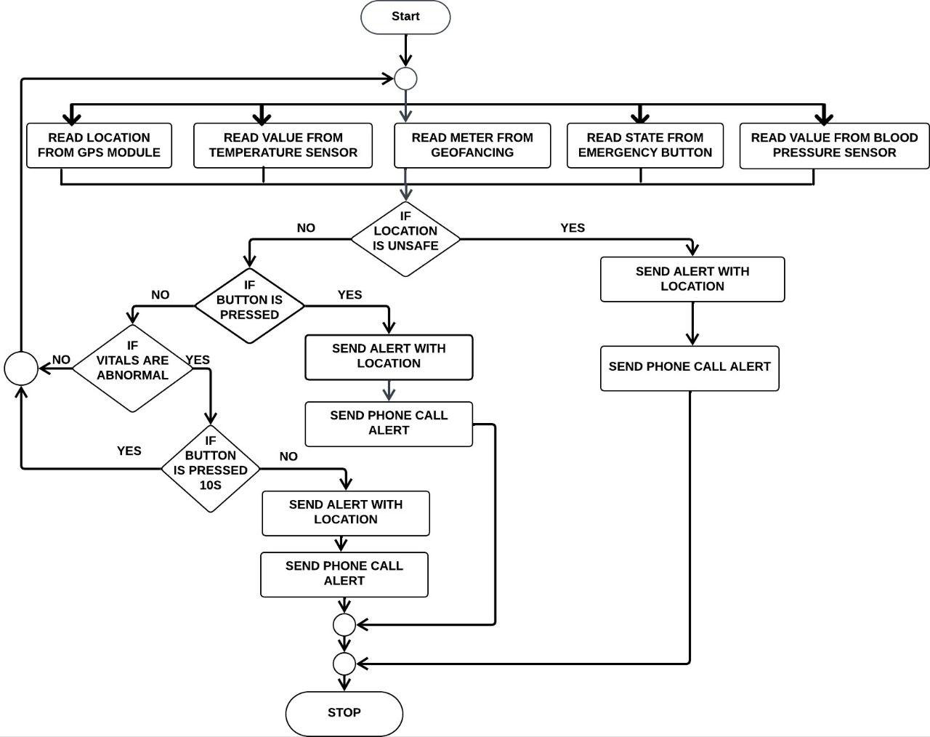

* 1. Solution & Technical Architecture

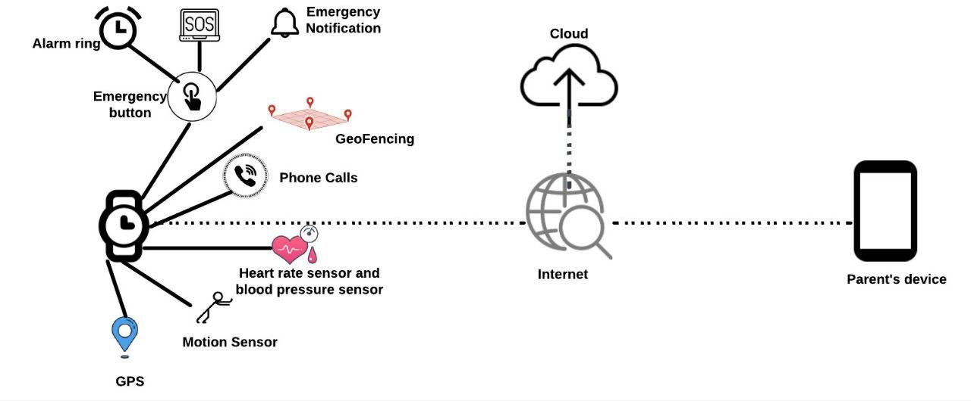

5.3 User Stories

|  |  |  |  |  |  |  |
| --- | --- | --- | --- | --- | --- | --- |
| **User Type** | **Functional Requirement (Epic)** | **User Story Number** | **User Story / Task** | **Acceptance criteria** | **Priority** | **Release** |
| Customer (Web user) | Registration | USN-1 | As a user, I can register for the application through Gmail | I can register through Gmail | High | Sprint- 1 |
| Customer (Web user) | Confirmation | USN-2 | As a user, I will receive confirmation email once I have registered for the application | I can receive confirmation email & click confirm | High | Sprint-1 |
| Customer (Web user) | Dashboard | USN-3 | As a user, I can get alert notification, when the child moves out of the geofence | I can get the alert about the child | Medium | Sprint- 2 |
| Customer (Web user) | Notification | USN-4 | As a user, I can track the child’s location | I can track location | High | Sprint- 1 |
| Administrator | Support | USN-5 | As a user, I will get a call incase of emergency | I will receive a phone call | High | Sprint- 3 |
| Customer (Web user) | Logout | USN-6 | As a user, I can logout of this application | I can logout | Low | Sprint- 4 |

**6.PROJECT PLANNING & SCHEDULING**

* 1. Sprint Planning & Estimation

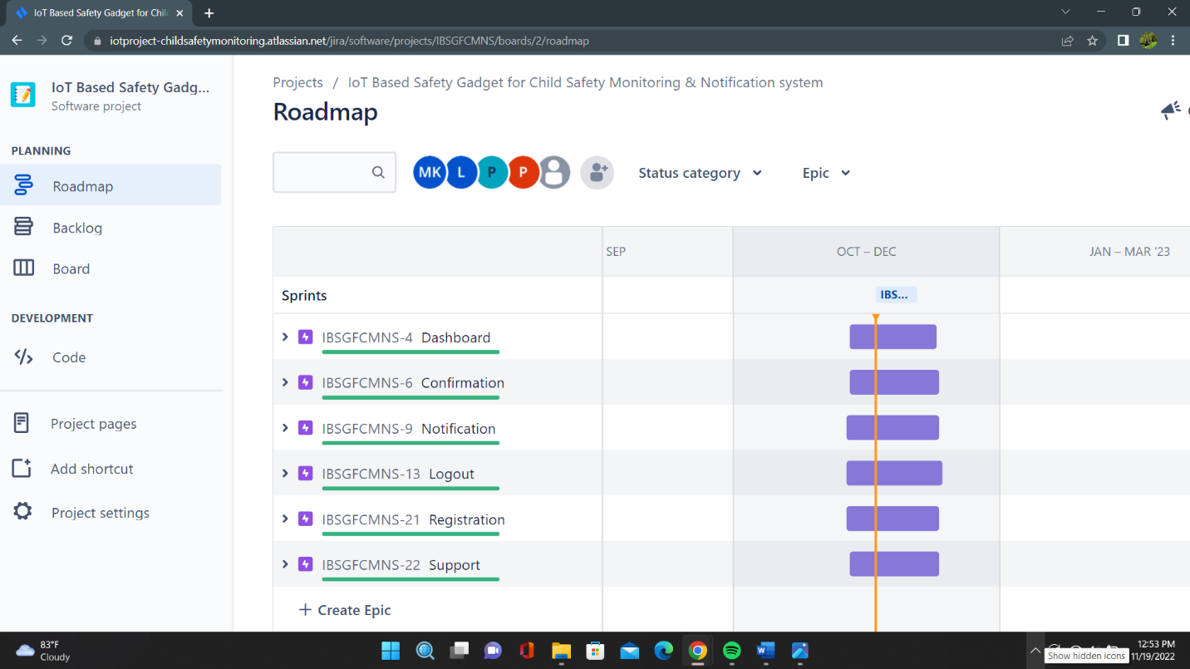

* 1. Sprint Delivery Schedule

| **Sprint** | **Total Story Points** | **Duration** | **Sprint Start Date** | **Sprint End Date (Planned)** | **Story Points Completed (as on Planned End Date)** | **Sprint Release Date (Actual)** |
| --- | --- | --- | --- | --- | --- | --- |
| Sprint-1 | 20 | 6 Days | 24 Oct 2022 | 29 Oct 2022 | 20 | 29 Oct 2022 |
| Sprint-2 | 20 | 6 Days | 31 Oct 2022 | 05 Nov 2022 | 20 | 05 Nov 2022 |
| Sprint-3 | 20 | 6 Days | 07 Nov 2022 | 12 Nov 2022 | 20 | 12 Nov 2022 |
| Sprint-4 | 20 | 6 Days | 14 Nov 2022 | 19 Nov 2022 | 20 | 19 Nov 2022 |

* 1. Reports from JIRA

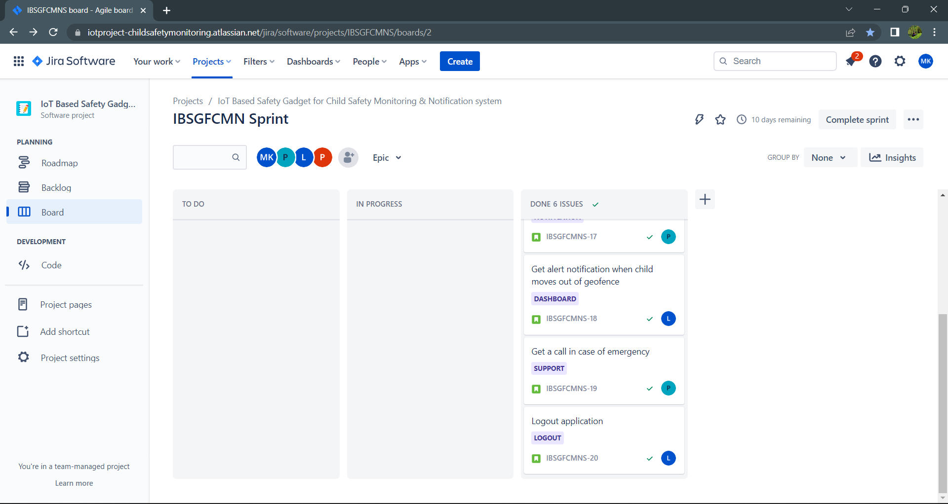

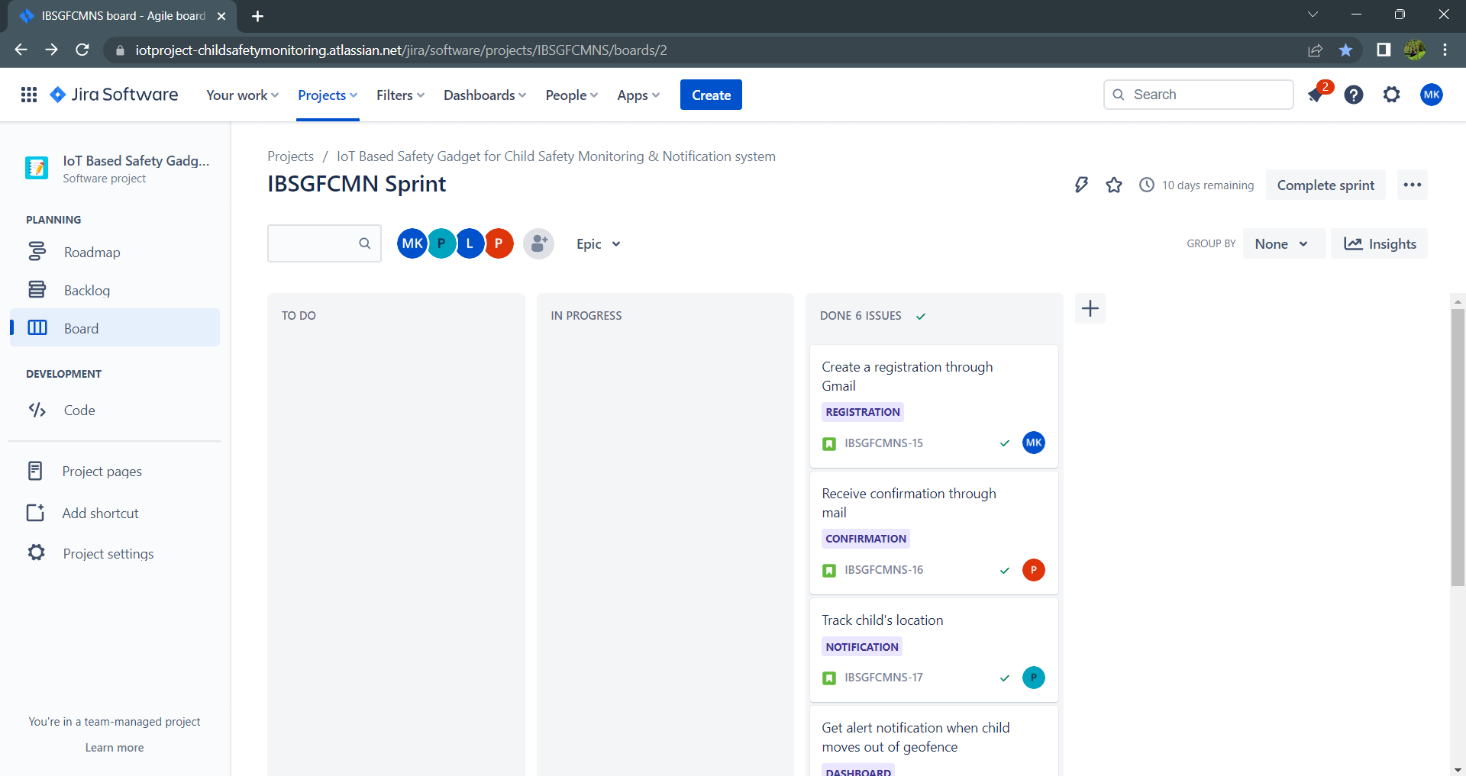

1. **CODING & SOLUTIONING (Explain the features added in the project along with code)**
   1. Feature 1
   2. Feature 2
   3. Database Schema (if Applicable)
2. **TESTING** 
   1. Test Cases
   2. User Acceptance Testing
3. **RESULTS**
   1. Performance Metrics
4. **ADVANTAGES & DISADVANTAGES**

**ADVANTAGES:**

* Children typically wander a lot. You can easily and quickly find out where your children are with GPS tracking gadgets.
* A child's Tracking device alerts parents to any potential risks and safeguards the child as a result.
* Keep your kids safe while they play and explore the neighbourhood. Parents who want to keep an eye on their children around-the-clock can consider our personal GPS trackers for children.
* It helps parents communicate and might be useful even when travelling.
* Family will be informed in full about their child boarding and disembarking the school bus. When the youngster does not board or leaves the bus at the opposite stop, they can also receive emergency notifications.

**DISADVANTAGES:**

* If they are not allowed to play with their electronics, young kids might not cooperate.
* Children who spend too much time on electronic devices may spend less time outside and have fewer social interactions.
* It could cause a lack of interest in daily activities and poor concentration during academics.
* A sedentary lifestyle, poor dietary habits, and increased gadget use are all risks.

**11.CONCLUSION**

This study shows how smart IoT devices can be used to track and protect children while also assisting parents in finding and keeping an eye on them. An SMS and phone call are sent to the parents' mobile phones if the sensor detects any unusual readings. Additionally, a cloud-based update to the parental control app. For communication between the safety device and the parent's phone, the system has GSM and GPS modules. In order to implement IoT and send all the monitored parameters to the cloud for Android app monitoring on a parent's phone, the system also includes a WiFi module.This research reveals how smart IoT devices can be used to track and protect children while also assisting parents in finding and keeping an eye on them. An SMS and phone call are sent to the parents' mobile phones if the sensor detects any unusual readings. Additionally, a cloud-based update to the parental control app. For communication between the safety device and the parent's phone, the system has GSM and GPS modules .

.

1. **FUTURE SCOPE**

This system can be further enhanced by installation of mini camera inside smart gadget for better security so that live footage can be seen on parental phone during panic situations. The system can be modified by installation of small solar panels for charging the battery of smart gadget to gain maximum battery backup. This wearable may additionally have a camera module included in to monitor the child's surroundings and provide a sharper picture of the area. Similar to how the GPS module gathers data, the camera will do the same.

1. **APPENDIX**

Source Code

GitHub & Project Demo Link

INTRODUCTION: